Pregnancy in human beings vs. dogs
Student’s Name
Institutional Affiliation
Date

Differences and similarities in human and dog pregnancy
Introduction
Both human beings and dogs belong to the kingdom Animalia. The two also belong to the same phylum (Chordata) and class (Mammalia). Their differences in the taxonomical classification start from the order, family, genus, species, and subspecies. Humans belong to Order Primates, Family Hominidae, Genus Homo, and Species Sapiens, while dogs belong to Order (Carnivora), Family (Canidae), Genus (Canis), Species (C. Lupus), and Subspecies (C.I. familiaris). Thus, humans and dogs have some differences and similarities in a wide range of aspects. The differences occur during copulation, number of offspring, menstrual cycle, and gestation period. This paper focuses on the reproduction aspect of the two creatures focusing on their pregnancy.
Differences
Differences in number of offspring
Human pregnancy is also called gestation. The gestation period is when an offspring develops inside a woman. There is a possibility of multiple pregnancies where they can result in twins, triplets, quadruplets, and so on. One of the differences between human and dog pregnancy relates to the number of possible offspring. Usually, dogs give birth to more offspring than human beings (Lamm & Makloski, 2012). Using the rule of thumb, a mammal produces half as many offspring as the number of teats of the female. Since a woman has two teats, going by the rule of thumb means she cab only have one child. A female dog has ten teats which means it can give birth to five puppies. Thus, the average number of offspring for a dog is five to six puppies. However, the rule of thumb is usually altered in domesticated animals. Unlike in dogs, where the breed of the dog can determine the number of offspring a dog has, humans’ number of offspring depends on a woman's fertility. Additionally, the number of offspring varies with the mother's age in dogs, whereby young and old age dogs are associated with smaller litter size. In humans, age and size are not significant factors in determining the number of children a woman will give birth to. Fertility in women depends on the type of food they take and some genetic factors. For example, a family with a history of twins is likely to repeat itself in the future.
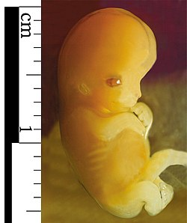
An embryo
Differences in gestation period
Another difference between human and dog pregnancy relates to the gestation period. Whereas humans have a gestation period of 40 weeks (around nine months), the gestation period of dogs is approximately 63 days (nine weeks). This means that the gestation period of dogs is way shorter than that of human beings. During the nine-month gestation period in humans, the baby grows in stages starting from the zygote to the fetus (Jukic et al., 2013). The first stage of baby formation is the zygote. A zygote forms when the male gamete (sperm) fuses with the female gamete (egg). Fertilization in human beings takes place in the fallopian tube. Although many sperms surround the egg for fertilization, only one sperm fertilizes the egg. After the zygote is formed, it continues to grow and becomes an embryo. Unlike the zygote, which is single-celled, the embryo is multicellular, and some have some body organs. The developing human being continues to be called an embryo until the ninth week of pregnancy, when it becomes a fetus. The fetus starts from the ninth week after fertilization and continues to birth. These stages of development, starting from zygote, embryo, and fetus, are only present in human beings and not dogs. This development happens over the nine months of pregnancy in women. The dog's embryo development only takes 63 days, which is why it is shorter than human beings.
Heat cycle in dogs
Another difference between human pregnancy and dog pregnancy is that before a dog gets pregnant, they go through the heat cycle, which humans do not have. The heat cycle is a pre-pregnancy stage in which the female dog becomes receptive to mating. It lasts between 18 and 21 days and is broken down into four stages. The heat cycle also forms the dog's reproductive cycle. The first stage is the proestrus stage which lasts for around nine days. In this stage, females start to attract males, although they reject the advances. Signs of this stage include swelling of the vulva and bloody discharge. The second stage is the estrus stage which lasts around seven to 11 days. In this stage, the female accepts the male's advances and allows mating. The vulva remains enlarged, although the bloody discharge lightens and reduces in volume. The third stage is the diestrus stage which occurs two weeks into the heat cycle. The females reject mating, and swelling and discharge cease. The last stage is the anestrus stage, which occurs after one heat cycle ends and the next one begins. It lasts about six months.
Human beings do not undergo these stages in pregnancy.
Differences during copulation
Just like human beings, copulation in dogs leads to pregnancy. Although in both humans and dogs, copulation involves the male's penis penetrating the female's vagina, in dogs, there is "tying" or "Knotting." This occurs when the bulbus glandis in males becomes engorged with blood while the female’s vagina contracts locking the male’s penis inside the female’s vagina. The male dogs have a locking bulbus glandis at the base of the penis, which, upon full penetration into the female vagina, expands and locks inside the vaginal, leading to "knotting." This is a significant difference with human beings because there is no "knotting" in humans. It is during the "knotting" in dogs that ejaculation slowly happens when semen slowly leaks into the vagina. The knotting usually takes between five and twenty minutes when the knot contracts allowing the dogs to separate.
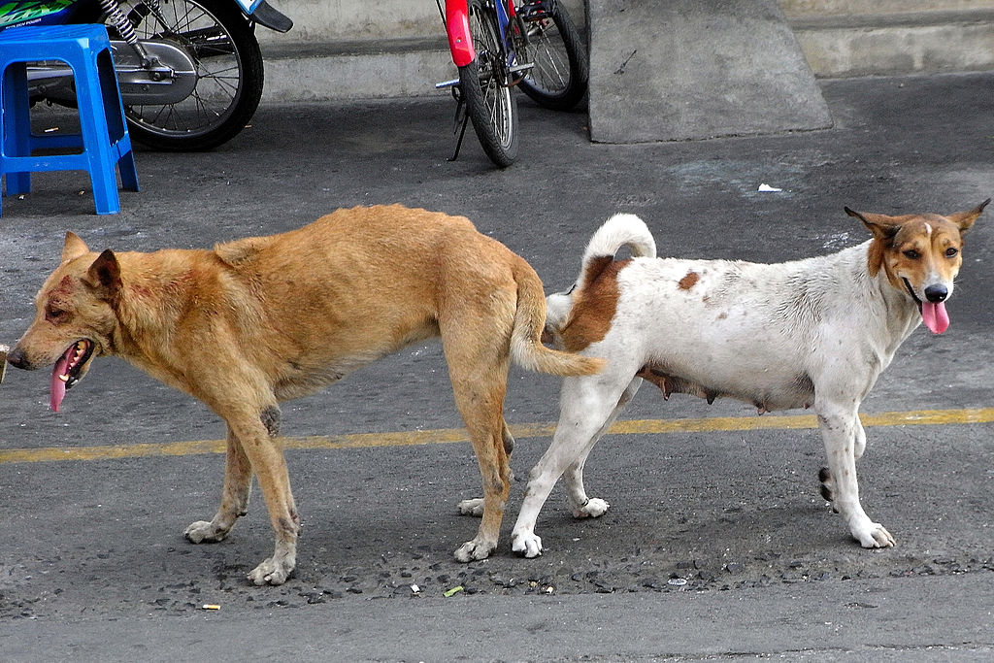

Another difference in copulation in dogs is that the male's penis becomes erect after penetrating the female. This is contrary to human beings, where the male's penis becomes erect before entering the female. In dogs, the penis penetrates first, then swelling occurs, which leads to an erection. This happens very quickly. How is the penis able to penetrate without being erect? The penis can penetrate the vagina because of a narrow bone called the "baculum," a common feature in many placental mammals. For human beings, erection can start as early as the male fantasizes about having sex. During copulation, a man's penis remains erect until he ejaculates, which marks the end of the erection. The penis cannot penetrate the vagina if it is not erect.
The menstrual period in human beings
Women in their reproductive age usually menstruate once a month. Unlike human beings, dogs do not menstruate. A woman’s pregnancy is determined by her menstrual cycle (Mihm et al., 2011). Menstruation signifies that pregnancy has not occurred. Menstruation typically starts from ages of 12 and 15 and stops occurring after menopause. However, it can begin as early as 8 or 9 years. Pregnancy can only occur during specific days of the month, depending on the woman's menstrual cycle. During the menstruation period that usually takes 2 to 7 days, the woman bleeds. Menstruation does not occur when a woman is pregnant. The menstrual cycle is caused by the rise and fall of hormones. The menstrual cycle usually happens once in a month (usually 28 days). The menstrual cycle determines when a woman can get pregnant. Ovulation usually takes place on the 14th day (Barbieri, 2014). Ovulation is the process by which an egg is released during menstruation. This is when the ovarian follicle discharges the egg (ovum or oocyte). When the ovum is released, it travels through the fallopian tube, where it may meet the sperm for fertilization.
A woman is most fertile within a day or two of ovulation (Reed & Carr, 2015. This is the ideal period to get pregnant. Since the egg has been released, if a woman has sex when ovulating, the sperms will meet the egg, and fertilization will lead to pregnancy (Barbieri, 2014). However, it is essential to note that it is possible to get pregnant in the days leading up to ovulation because of the sperm for several days inside the woman's body. When a woman is least likely to get pregnant, the days of the menstrual cycle are colloquially referred to as the "safe period." The safe period refers to when the egg is not available for fertilization either because it has not been released or has broken down to form the menstrual blood. Therefore, pregnancy cannot occur during the safe period; instead, it can only occur during the "unsafe period."
Dogs do not have a menstrual cycle. However, this does not mean that they can get pregnant any day. Dogs have the heat cycle. Female dogs go into heat every six months on average, although this varies between dogs. The dog can only get pregnant during the second stage of the heat cycle, called the estrus stage. This is when the female dog attracts males and accepts mating. Thus, it is not the typical menstrual period that human females undergo; rather, female dogs undergo four stages in their reproductive cycle (proestrus, estrus, diestrus, anestrus).
Similarities
There are many similarities between human and dog pregnancy. This is attributed to the fact that they belong the same kingdom, phylum, and class. First, pregnancy in both dogs and humans starts after fertilizing the female egg by the male sperm after mating. The fusion of a sperm and an egg in the ampulla of the fallopian tube is known as fertilization (Georgadaki et al., 2016). As a result of this union, a zygote cell, or fertilized egg, is formed, kicking off pregnancy growth in the womb of the females of both humans and dogs. The attachment of the zygote to the womb is known as implantation. The spermatozoa usually take some hours before fertilizing the eggs in both dogs and humans.
Secondly, during pregnancy, both humans and dogs experience enlargement of the nipples. The nipples start to become much more extensive and softer as the body prepares to give birth (Motosko et al., 2017). It is also possible for the nipples in both humans and dogs to change form and start to darken. The human and dog's nipples usually are tiny; during the early stages of pregnancy, her nipples grow in size. Compared to their usual flatness, the areolas in female dogs and women become rounded during the pregnancy period. On some occasions, the mammary glands may start to produce colostrum before birth in dogs and humans (Lazama et al., 2019).
The other similarity is that both humans and dogs experience almost the same signs of pregnancy. For example, morning sickness is a common symptom in both dogs and humans. Morning sickness has no common cause but is stimulated by increased hormone levels during the early stages of pregnancy in both humans and dogs. Some dogs get morning sickness during the third or fourth week of pregnancy but only for a few days. In humans, morning sickness occurs during the first trimester of the gestation period. Many pregnancies in humans are accompanied by morning sickness as signs and symptoms of pregnancy (Motosko et al., 2017).
Significant changes in the bodyweight of females occur in both dogs and humans during pregnancy. Changes in body weights start during the early stages of pregnancy and increase more and more towards the late stages of pregnancy for both humans and dogs. The weight increases not only because of the developing baby or puppy but also because of increased fluid in the body needed for the baby's circulatory system, fetal membranes, and amniotic fluids. The weight gains usually occur at the abdomen of dogs and humans. An increase in body weight can also be attributed to increased appetite and feeding during pregnancy in dogs and humans.
During pregnancy, enlargement of the abdomen occurs in both humans and dogs. The stomach growth during the late pregnancy period is caused by polyhydramnios, abdominal congestion due to fetal development, and hypothyroidism. The enlargement of the abdomen is among the clearest indicator of pregnancy in both dogs and humans. For some humans and dogs, abdomen enlargement does not occur much during the first stages of the first trimester of the pregnancy. However, the abdomen enlargement can be noticed by the mother to have started taking place towards the end of the first trimester. During the second and the third trimesters, the abdomen enlargement is easily noticeable as this is when the fetus develops standard differentiating features such as the skeletal structure.
Fetus development occurs in the uterus wall in the reproductive system of both dogs and humans during pregnancy. The fertilized embryo implants in the uterine wall, where it develops into an embryo attached to the placenta and encircled by fluid-filled membranes in humans. A similar occasion also happens in dogs, where the development of the fetus takes place in the uterus. The process of implantation occurs after some days in both dogs and humans.
Pregnancy in dogs and humans occurs in three known trimesters, namely, first trimester, second trimester, and third trimester. The completion of these stages marks the development of a baby or a puppy in humans and dogs. The trimesters in human pregnancy are divided into three months each.
During the first trimester, multiple cell division occurs in both the dog and humans. The fertilized embryo nests itself to the uterine wall during this stage in both humans and dogs. During this stage, the brain and spinal cord start to form as well as other body organs. The first pregnancy symptoms, such as nausea, vomiting, and tiredness, are witnessed in this stage for both dogs and humans. At this stage, variation in the appetite may also occur for both the dog and woman. The desire for food at this stage is likely to reduce in dogs and women.
In the second trimester, physical changes start to occur in both dogs and humans. Material changes such as belly expansion and an increase in mammary glands occur rapidly in both humans and dogs. The uterine walls also expand to allow for the accumulation of the growing fetus in humans and dogs. The weights also start to increase significantly at this level for both dogs and humans. Fetal tissues also continue to differentiate into separate structures and organs. The fetus also starts to grow in size and length at this stage.
During the third trimester, a variety of similar activities occurs in both dogs and humans. Firstly, the fetus starts to develop fine hair on the head for humans and puppies' skin. Secondly, the fetus begins to gain rapid body weight in both humans and dogs at this stage of development. Thirdly, fetal movement can be felt in both humans and dogs as a result of kicking and stretching of the fetus. Fetal skeletons continue to utilize more minerals and final structures develop. In general, it is in the third trimester that the fetus develops completely in the human and dogs’ wombs.
During pregnancy, the fetus for both humans and dogs floats in the amniotic fluid. Amniotic fluid plays similar roles during pregnancy in both dogs and humans. Firstly, it enables the free movement of the fetus in the womb during the entire pregnancy period enhancing the proper development of bones. Secondly, the amniotic fluid provides a suitable temperature for the development of the fetus in both dogs and humans. Thirdly, the amniotic juice prevents exertion of pressure on the umbilical cord and prevents the fetus's injury from external factors. At the time of birth, the amniotic fluid comes out first to enable free movement of the baby or puppy out of the mother’s reproductive system.
In both humans and dogs, the size of the vagina starts to increase gradually from the first trimester to the third trimester during the pregnancy period. The increase in size means creating and enabling easy passage of the baby in humans or puppy dogs during birth.
Placenta development occurs in both humans and dogs during pregnancy. The placenta develops in the uterus and plays an essential role by linking the fetus and the mother for both dogs and humans. It is responsible for the transportation of oxygen and nutrients to the fetus through the umbilical cord. It also excretes waste products from the fetus in humans and dogs (Graubner et al., 2018).
Lastly, both dogs and humans, pregnancy is by sexual intercourse. In both humans and dogs, pregnancy occurs by sexual intercourse between the male and female. Due to improved technology, pregnancy can also happen through assisted reproductive technology procedures like In-Vitro fertilization in humans. For dogs, artificial insemination is used. Fertilization in both cases occur internally.

References
Barbieri, R. L. (2014). The endocrinology of the menstrual cycle. In Human Fertility (pp. 145-169). Humana Press, New York, NY.
Georgadaki, K., Khoury, N., Spandidos, D. A., & Zoumpourlis, V. (2016). The molecular basis of fertilization. International Journal of molecular medicine, 38(4), 979-986.
Graubner, F. R., Boos, A., Aslan, S., Kücükaslan, I., & Kowalewski, M. P. (2018). Uterine and placental distribution of selected extracellular matrix (ECM) components in the dog. Reproduction, 155(5), 403-421.
Jukic, A. M., Baird, D. D., Weinberg, C. R., McConnaughey, D. R., & Wilcox, A. J. (2013). Length of human pregnancy and contributors to its natural variation. Human Reproduction, 28(10), 2848-2855.
Lamm, C. G., & Makloski, C. L. (2012). Current advances in gestation and parturition in cats and dogs. Veterinary Clinics: Small Animal Practice, 42(3), 445-456.
Lezama-García, K., Mariti, C., Mota-Rojas, D., Martínez-Burnes, J., Barrios-García, H., & Gazzano, A. (2019). Maternal behaviour in domestic dogs. International journal of veterinary science and medicine, 7(1), 20-30.
Mihm, M., Gangooly, S., & Muttukrishna, S. (2011). The normal menstrual cycle in women. Animal reproduction science, 124(3-4), 229-236.
Motosko, C. C., Bieber, A. K., Pomeranz, M. K., Stein, J. A., & Martires, K. J. (2017). Physiologic changes of pregnancy: A review of the literature. International journal of women's dermatology, 3(4), 219-224.
Reed, B. G., & Carr, B. R. (2015). The normal menstrual cycle and the control of ovulation.

